1. MODEL SUMMARY

A1+A2. Background Information
Metric | Value
Competition Name | MITSUI&CO. Commodity Prediction Challenge
Team Name | Muurur - (Solo)
Private Leaderboard Score | 0.447
Private Leaderboard Place | 14th
Name | Stefan Kerren
Location | Germany
Email | stefan.kerren@googlemail.com
Background | Data Scientist in Supply Chain Analytics with a B.Sc. focusing on ML.
Motivation | I entered because I enjoy solving regression problems, have an interest in financial markets and like ML-Competitions that don’t require expensive hardware. Also this was my first Kaggle Competition
Time Spent | 40-60 Hours

A3. Summary
The goal was to rank financial asset classes by Sharpe ratio over time. I established a baseline using a Ridge Regression model on log-returns early in the competition. After extensive experimentation with complex non-linear models(Boosted Trees) and Time Series approaches, I observed that these methods failed to consistently outperform the linear baseline. Consequently, the final submission relied on this simple baseline I established.

A4. Features Selection / Engineering
- I only used one feature: the logarithmic returns.
- I selected this feature because whenever I added more features it just added additional noise and did not improve the signal. Especially since I trained an individual model for each pair_id adding any information on the assets itself seemed unnecessary.
- I had a bug in my Feature Engineering on the prediction Pipeline that caused me to generate returns one day shifted in the past instead of the current day. (This was unintentional)

A5: Training Method(s)
- Algorithm: Scikit-learn Ridge Regression.
- Parameters: Standard default parameters.
- Training Scope: Trained on all available log-returns for each specific target pair until date_id 1917. I did not include the additional data from the data update.

A6: Interesting Findings
While the winning submission was initially established as a baseline, a retrospective backtest reveals why it is not a bad approach to the competition.

In a 90-day competition window based on real market data, market regime changes can make results highly variable. To win, a model requires, either a consistent edge that is universal in each market, or a positive mean combined with enough variance to capture upside potential during specific market conditions.
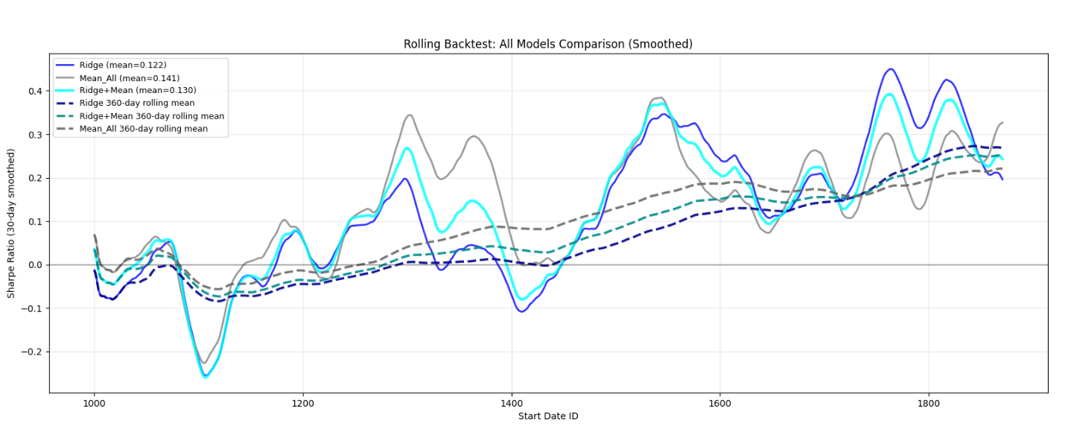

Backtesting Results: I conducted a rolling backtest (training on the full available dataset from date_id 1000 , evaluating on 90 days before retraining) comparing the Ridge approach against Mean-only models. I found that the only mean model that can generate a consistent positive sharpe ratio was calculating a mean over all available data. In the backtest I also tried combining the mean model with the ridge regression but found that this approach just diminishes the high highs from the Ridge regression Model while not offsetting the lows.

The analysis shows that while the Mean model is stable, the Ridge Regression model demonstrates higher variance and higher peaks.

Crucially, in the last year of market data, the Ridge Regression performance trended upward, outperforming the rolling mean baseline.

In future competition especially regarding financial data I will spent more time establishing a baseline and backtesting heavily with compute friendly methods.

A7. Simple Features and Methods
The method is extremely simple and compute efficient but as the backtest shows it is still dependant on market conditions.

A8. Model Execution Time
Metric | Time
Training Time | < 5 Seconds
Inference Time | < 5 Seconds

